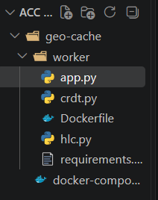
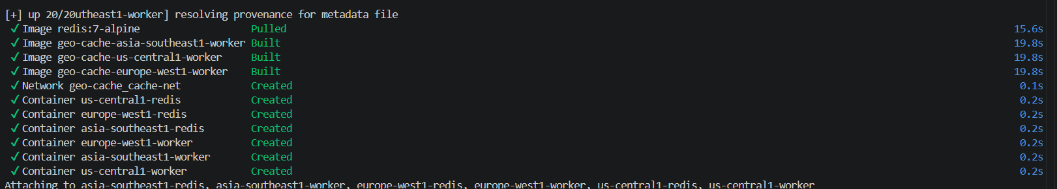
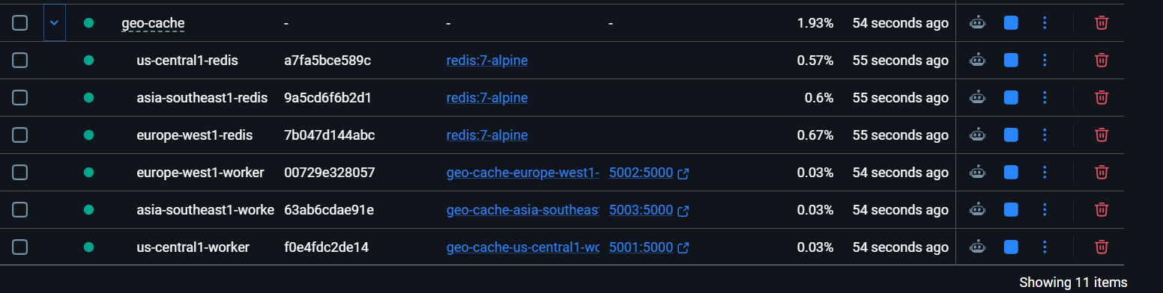
Flask endpoints - /set, /get/<key>, /incr, /counter/<key>, /sync, and /health
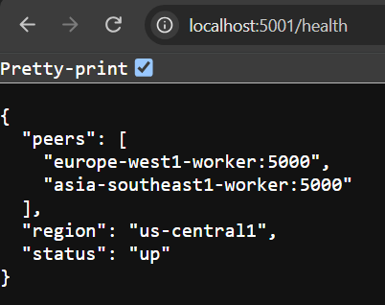
5001 - us, 5002 - europe, 5003 - asia
TESTING

- Basic write with convergence
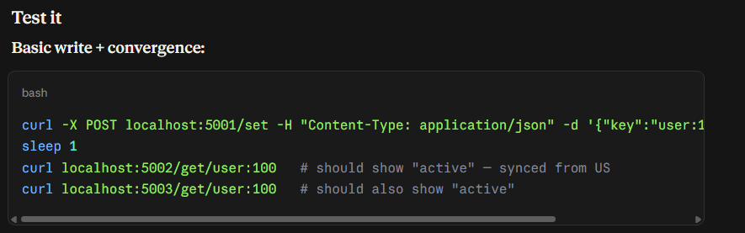
Sent http request to 5001 (us) and asia and europe got synced

- Conflicting write - CRDT
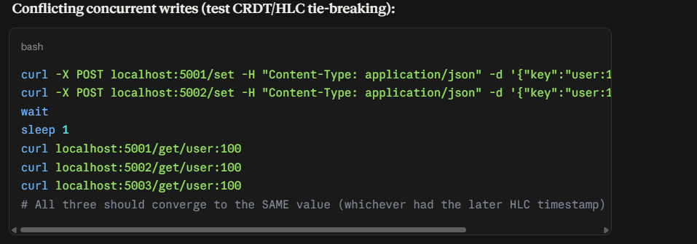
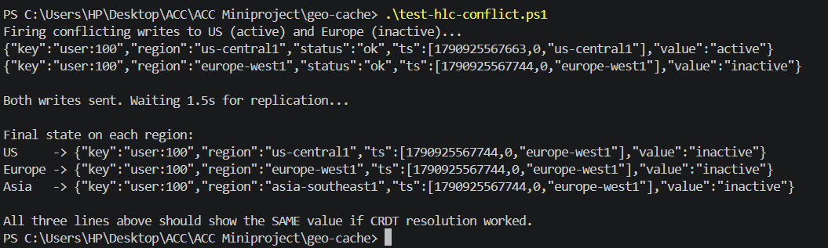

- Conflicting/Simultaneous likes - PN-Counter
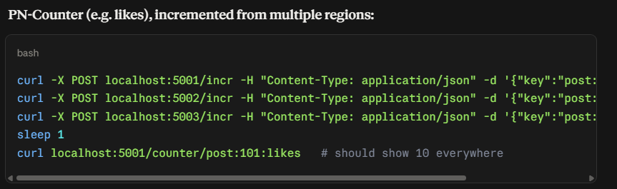
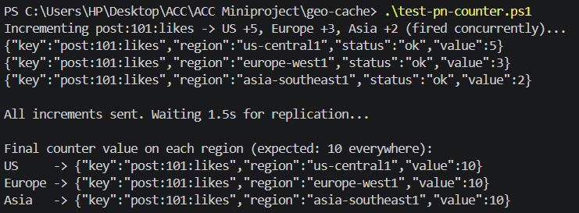

- One node goes down (no network), syncs with all after getting network

All are up
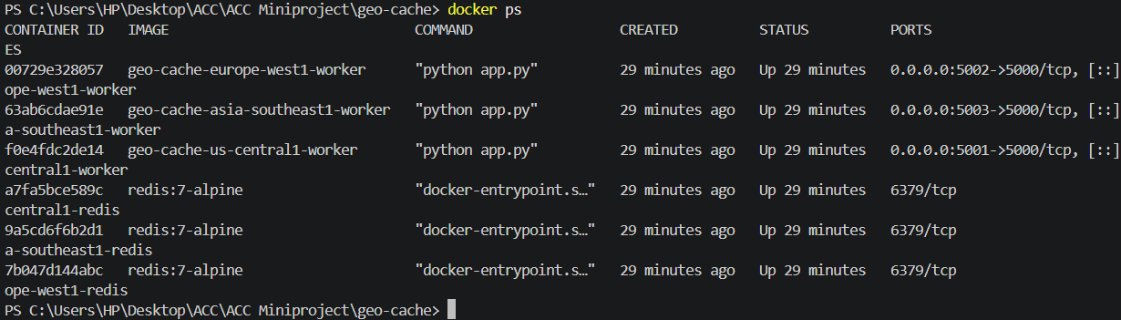
Europe and us paused for asia - asia goes out of n/w (DO NOT DISCONNECT)
Send req to asia (user: 100, hlc timestamp: 1790926769686)
Unpause them i.e asia back in n/w
They sync with asia, so europe and us have the user 100 with same hlc
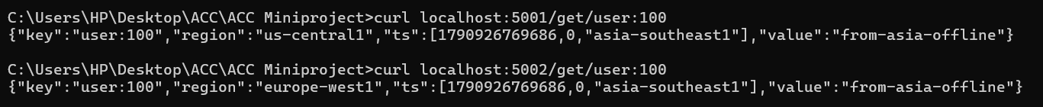

IMP FINDING


